Test Plan and Baseline Testing Results for the
MEPAS Surface Water (Non-Tidal River) Transport Module

1.0 Background and Scope

This paper presents a test plan and the baseline testing results for the Multimedia Environmental Pollutant Assessment System (MEPAS) surface water transport module. The purpose of the surface water transport module is to simulate the migration and fate of chemical and radionuclide constituents through non-tidal rivers. The surface water transport module is specifically designed as an object for inclusion into the Framework for Risk Analysis in Multimedia Environmental Systems (FRAMES), which is a platform that allows for the linking of various multimedia modules into complete transport/exposure assessment systems (Whelan et al., 1997).

The surface water transport module is being baseline tested for MEPAS version 4.1 and FRAMES version 1.1. The suite of test cases developed for this testing, and presented in this paper, will also be used for assessing the effects of future code modifications. Each time a modification is made to the program code, these test cases are rerun, and their results are compared to the previous run (regression testing). Changes in the results are evaluated to determine if they were expected due to the modification and are an acceptable change, or they are an unintended side effect. In the latter case, the program code can be changed and the testing performed again.

As currently designed, the surface water module consists of three components: a Module User Interface (MUI), a pre-processor, and the model itself. The MUI (RIV.EXE - version date) obtains the medium physical properties from the user and stores this data in the Global Input Data (GID) file. The pre-processor (PRERIV.EXE - version date) reads the GID file and the Water Flux File (WFF) and prepares a model specific input file (*.WIN). The model (RADCON.EXE - Version 06/18/1999) reads the *.WIN file, performs the simulation, and outputs the results directly to the WFF for contaminant mass flux results, or the Water Concentration File (WCF) for contaminant aqueous concentration results. The following sections list the requirements of the surface water transport module, explains how these requirements relate to the specific test cases in this plan, and then presents the test cases themselves.

2.0 Requirements

Requirements for the surface water transport module are described in the paper entitled, Requirements for the MEPAS Surface Water (Non-Tidal River) Transport Module. These requirements have been reworded into the following list of concise, fundamental requirements suitable for testing.

Requirement  Number | Requirement
1 | Correctly read and write data from/to the Global Input Data (GID) file
2 | Correctly read and write data from/to the Water Flux File (WFF)
3 | Correctly write data to the Water Concentration File (WCF)
4 | Simulate contaminant migration, via one dimension, for both chemicals and radionuclides through non-tidal rivers
5 | Conserve mass in the simulation
6 | Be able to account for the ingrowth of progeny resulting from degradation/decay, and be able to handle decay chains with up to 9 members (i.e., one parent and eight progeny)
7 | Output contaminant concentration results over a time interval that 1) is sufficient to demonstrate mass conservation, and 2) does not include large intervals where the mass flux or concentration results are zero or near zero
8 | Have no limits on the number of constituents considered in a scenario
9 | Have no limits on the number of flux/concentration records read from the input files
10 | Have no limits on the number of flux/concentration records written to the output files
11 | Have no limits on the number of receptors considered in a scenario
12 | Function within the Windows 95 operating system
13 | Create an error file (*.ERR) at the start of model execution
14 | When an error condition occurs, write an error message to the error file and immediately cease model execution
15 | Delete the error file if the model runs to completion without error
16 | Create a warning file (*.WRN) at the start of model execution
17 | When a warning condition occurs, write a warning message to the warning file and continue model execution
18 | Have a user-friendly Module User Interface (i.e., the MUI shall have the same functionality as standard Windows 95 software) with an on-line help feature providing the user with easy-to-understand descriptions of all input parameters entered through the MUI
19 | Provide choices to the user regarding parameter units for data entered into the MUI
20 | The MUI shall require only those data necessary to perform the simulation
21 | Produce a list file (*.WLS file) that documents the data actually read in by the model and summarizes intermediate calculation results and simulation results
22 | Simulate dispersion in contaminant transport in one dimension (lateral or y-direction)
23 | Compute contaminant aqueous concentrations at the river (downgradient) boundary

The following table shows the relationship between these requirements and the test cases described in Section 3. Although some requirements are applicable to all test cases (e.g., function within Windows 95), this table mainly shows which requirements are intended to be tested by each case. There are no test cases for requirements 9 and 10. This is because the module cannot currently read/write an unlimited number of records from/to the input/output files.

Requirement | Test Case Number
Requirement | 01 | 02 | 03 | 04 | 05 | 06 | 07
1 | X
2 | X
3 | X
4 | X | X | X | X
5 | X
6 |  | X
7 | X
8 |  |  |  |  | X
9
10
11 |  |  |  |  |  | X
12 | X
13 | X
14 |  |  |  |  |  |  | X
15 | X
16 | X
17
18 | X
19 | X
20 | X
21 | X
22 | X | X | X | X
23 | X | X | X | X

3.0 Test Cases and Baseline Testing Results

This section describes the specific test cases used for baseline testing of the MEPAS surface water transport module. Calculations performed to determine expected results are shown in Appendix A for the appropriate test cases. Appendix B describes the general procedure for conducting the tests.

3.1 RIVER01

3.1.1 Description and Rationale

This is a simple case to verify the basic functions of the surface water module. One chemical (no degradation) and one radionuclide will be released to a river. The source emission for both constituents will be at steady-state for a duration of 100 years. The distance from the source to the receptor will be large enough for the contaminants to be fully mixed across the width of the river (the module assumes that contaminants are always fully-mixed vertically). The radionuclide will produce no progeny, and the half-life of the radionuclide will be approximately equal to the travel time from the source to the receptor. The following will be evaluated: 1) user-friendliness of the MUI, 2) on-line help in the MUI, 3) data requested by the MUI, 4) data transfer from the MUI to the GID file, from the GID file to the WIN file, from the WIN file to the model, from the WFF to the preprocessor, and from the preprocessor to the model, 5) mass (or activity) conservation, 6) calculation of the lateral dispersion coefficient, 7) calculation of decay constants, 8) computation of contaminant concentration at the receptor location, 9) the appropriateness of the time interval over which the results are output, and 10) the creating of the .WLS file.

3.1.2 Input Data

The constituent-specific input data for this case is as follows:

Constituents | Acetone | Yttrium-90
Inventory | 100,000 g | 1.0 Ci
Emission Rate | 1000 g/yr | 0.01 Ci/yr
Emission Duration | 100 yrs | 100 yrs
Half-life | n/a | 7.39 x 10⁻³ yrs

The source dimensions and medium physical properties are as follows:

Source Width | 25 m
Water Flux Through Source | 2785 m³/yr
Channel Depth | 2.44 m
Channel Width | 38.1 m
Average Annual Flow Velocity | 1.03 m/s
Average Annual Discharge at the Receptor | 95.75 m³/s
Distance to Receptor | 240.2 Km

3.1.3 Expected Results

It is expected that the MUI will be easy to use, have a functionality consistent with standard Windows 95 software, and that the on-line help will be clear and correct. It is expected that the MUI will request only the following information: channel depth, channel width, average annual flow velocity, average annual discharge at the receptor, and distance to receptor. It is expected that the transfer of data from the MUI to the GID file, to the WIN file, and then to the model will occur properly and that any necessary unit conversions will be done correctly. Further, the transfer of information from the WFF through the pre-processor to the WIN file, and then to the model will also occur without error and that any necessary unit conversions will be done correctly. The transfer of data between files can be confirmed by visual inspection of these files (RIVER01.GID and MEPAS_RV.WIN) and the MEPAS_RV.WLS file. It is also expected that at the start of model execution, a warning file (MEPAS_RV.WRN) will be created and remain in the workspace after model execution has terminated whether any warning messages occur or not. An error file will also be created (MEPAS_RV.ERR) at the start of model execution and deleted after model completion if no errors occurred. To test for the creation of this file, terminate model execution early using “ctrl-c” from the keyboard.

It is expected that the model will compute the following: a lateral dispersion coefficient of 1508 cm²/s and a decay constant for Yttrium-90 of 93.8 yr⁻¹ (both can be verified by visual inspection of the MEPAS_RV.WLS file). All of the following results can be confirmed by inspecting RIVER01.WCF. It is expected that the concentration of acetone and Yttrium-90 will be steady-state for 100 years at values of 3.31 x 10⁻¹³ g/mL and 1.66 x 10⁻⁶ pCi/mL, respectively (calculations are documented in Appendix A). It is expected that the total mass of acetone passing the receptor will be equal to its starting inventory (100,000 g), and that the activity of Yttrium-90 passing the receptor will be about half its starting inventory (0.50 Ci) (because the travel time to the receptor is equal to the half-life of Yttrium-90). These values will have to be computed from data in the WCF. Further, it is expected that the time interval over which the results are output will properly define the contaminant concentrations without having a large interval over which the results are zero or near zero.

3.1.4 Baseline Testing Results

When setting up this case, the ease-of-use and functionality of the surface water module MUI was evaluated. Several issues were identified and communicated to the MUI programmer, however, none of these issues prevented the MUI from functioning as they mainly dealt with user-friendliness. The on-line help for the MUI was reviewed and revised to be more clear and correct. The MUI requested only the information necessary to perform the simulation (i.e., all required parameters were asked for with no extra parameters being required).

The transfer of information from the MUI to the GID file, from the GID file to the model input file, and then from the input file to the model itself was evaluated. All information was transferred correctly and the necessary unit conversions occurred without error. The transfer of information from the input WFF to the model input file and then the model itself was also evaluated. At the start of model execution, a warning file was created, which remained in the workspace after execution was completed. The creation of the error file was checked by issuing “ctrl-c” during model execution. The error file is being created correctly, and is being deleted after the model runs to completion.

The model computed the following: a lateral dispersion coefficient of 1508 cm²/s and a decay constant for Yttrium-90 of 93.8 yr⁻¹. These values match the expected results exactly. The concentrations of acetone and Yttrium-90 were steady-state for 100 years at values of 3.31 x 10⁻¹³ g/mL and 1.66 x 10⁻⁶ pCi/mL, respectively, which also match the expected results exactly. The total mass of acetone passing the usage location was 98,742 g, and the total activity of Yttrium-90 passing the usage location was 0.494 Ci (these results were computed from the concentrations in the WCF and the water discharge, since the contaminant is fully mixed across the river). These results are slightly below the expected results and can be attributed to the poor resolution of the steep rising limb of the output results. The time interval over which the output results were reported provided good resolution (except for the steep rising limb) without any large time periods over which the result was zero or very near zero.

3.2 RIVER02

3.2.1 Description and Rationale

The intent of this case is to verify that decay products are handled correctly and to verify that concentrations are computed correctly when the contaminant is not fully mixed laterally. This case will release a chemical and radionuclide (having two decay products) to a river. The distance to the receptor will be such that full lateral mixing is not achieved.

3.2.2 Input Data

The constituent-specific input data for this case is as follows:

Constituents | Trichloroethylene | Einsteinium-254 | Californium-250 | Curium-246
Inventory | 51,500 g | 1.0 x 10⁷ Ci | 0.0 Ci | 0.0 Ci
Emission Rate | 51,500 g/yr | 1.0 x 10⁶ Ci/yr | 0.0 Ci/yr | 0.0 Ci/yr
Emission Duration | 1 yrs | 10 yrs | 1 yrs | 1 yrs
Half-life | n/a | 4.5 x 10⁻³ yrs | 13.1 yrs | 4,780 yrs

The source dimensions and medium physical properties are as follows:

Source Width | 25 m
Water Flux Through Source | 2785 m³/yr
Channel Depth | 6.01 m
Channel Width | 457 m
Average Annual Flow Velocity | 1.22 m/s
Average Annual Discharge at the Receptor | 3350 m³/s
Distance to Receptor | 500 m

3.2.3 Expected Results

The expected steady-state concentration for trichloroethylene is 9.39 x 10⁻¹² g/mL, and the expected steady-state concentrations for Einsteinium-254, Californium-250, and Curium-246 are 1.82 x 10² pCi/mL, 1.26 x 10⁻⁴ pCi/mL, and 1.20 x 10⁻¹³ pCi/mL, respectively (calculations are documented in Appendix A).

3.2.4 Baseline Testing Results

The steady-state concentration for trichloroethylene was 9.37 x 10⁻¹² g/mL, and the steady-state concentrations for Einsteinium-254, Californium-250, and Curium-246 were 1.82 x 10² pCi/mL, 1.26 x 10⁻⁴ pCi/mL, and 1.20 x 10⁻¹³ pCi/mL, respectively. These results match the expected results very well.

3.3 RIVER03

3.3.1 Description and Rationale

The intent of this case is to verify that concentrations are computed correctly when the receptor location resides within the source. One chemical (no degradation) and one radionuclide will be released to a river. The source emission for both constituents will be at steady-state for a duration of 100 years. The distance from the source to the receptor will be less than half the width of the source.

3.3.2 Input Data

The constituent-specific input data for this case is as follows:

Constituents | Acetone | Yttrium-90
Inventory | 1.0 x 10⁷ g | 1.0 x 10⁵ Ci
Emission Rate | 1.0 x 10⁶ g/yr | 1.0 x 10⁴ Ci/yr
Emission Duration | 10 yrs | 10 yrs
Half-life | n/a | 7.39 x 10⁻³ yrs

The source dimensions and medium physical properties are as follows:

Source Width | 100 m
Water Flux Through Source | 9140 m³/yr
Channel Depth | 9.14 m
Channel Width | 124 m
Average Annual Flow Velocity | 0.124 m/s
Average Annual Discharge at the Receptor | 140.5 m³/s
Distance to Receptor | 35 m

3.3.3 Expected Results

The expected steady-state concentrations for acetone and Yttrium-90 are 2.78 x 10⁻⁹ g/mL 27.8 pCi/mL, respectively (calculations are documented in Appendix A).

3.3.4 Baseline Testing Results

The steady-state concentrations for acetone and Yttrium-90 were 2.79 x 10⁻⁹ g/mL and 27.8 pCi/mL, respectively. These results match the expected results very well.

3.4 RIVER04

3.4.1 Description and Rationale

This case verifies that concentrations are computed correctly when dilution due to inflowing tributary water between the source and receptor is considered. One chemical (no degradation) and one radionuclide will be released to a river. The source emission for both constituents will be at steady-state for a duration of 100 years. The distance from the source to the receptor will be less than half the width of the source.

3.4.2 Input Data

The constituent-specific input data for this case is as follows:

Constituents | Acetone | Yttrium-90
Inventory | 1.0 x 10⁷ g | 1.0 x 10⁵ Ci
Emission Rate | 1.0 x 10⁶ g/yr | 1.0 x 10⁴ Ci/yr
Emission Duration | 10 yrs | 10 yrs
Half-life | n/a | 7.39 x 10⁻³ yrs

The source dimensions and medium physical properties are as follows:

Source Width | 85 m
Water Flux Through Source | 7240 m³/yr
Channel Depth | 9.14 m
Channel Width | 1520 m
Average Annual Flow Velocity | 1.07 m/s
Average Annual Discharge at the Receptor | 16300 m³/s
Distance to Receptor | 6.2 Km

3.4.3 Expected Results

The expected steady-state concentrations for acetone and Yttrium-90 are 2.86 x 10⁻¹¹ g/mL 2.81 x 10⁻¹ pCi/mL, respectively (calculations are documented in Appendix A).

3.4.4 Baseline Testing Results

The steady-state concentrations for acetone and Yttrium-90 were 2.86 x 10⁻¹¹ g/mL and 2.81 x 10⁻¹ pCi/mL, respectively. These results match the expected results exactly.

3.5 RIVER05

3.5.1 Description and Rationale

This case addresses the requirement that there be no limit to the number of constituents considered in a scenario. Twenty-one parent constituents will be selected to demonstrate that the 20-contaminant limit (which was present in MEPAS 3.2 and earlier versions) is no longer a concern for MEPAS 4.0. The parent constituents will include Uranium-238 (which has 8 decay products in MEPAS) thereby testing the requirement that the module be able to handle 9-member decay chains. The endpoint will be contaminant mass (or activity) exiting the medium.

3.5.2 Input Data

The parent constituents will be Americium-241, Cesium-137+D, Iodine-129, Plutonium-240, Technetium-99, Uranium-238, Acetone, Aroclor 1221, Benzo(a)pyrene, Chlorobenzene, Chromium VI, 1,2-Dichloroethylene, Ethylene Glycol, Hexachlorobenzene, Mercury, Naphthalene, Pyrene, Selenium, Toluene, Vinyl Chloride, and Xylene. The source emission to the river for each constituent will be a unit flux for 100 years. Other input data is as follows:

Source Width | 150 m
Water Flux Through Source | 9320 m³/yr
Channel Depth | 3.05 m
Channel Width | 101 m
Average Annual Flow Velocity | 0.86 m/s
Average Annual Discharge at the Receptor | 265 m³/s
Distance to Receptor | 800 m

3.5.3 Expected Results

It is expected that the module will run on all 21 parent constituents without error.

3.5.4 Baseline Testing Results

The module ran on all 21 parent constituents without error.

3.6 RIVER06

3.6.1 Description and Rationale

This case addresses the requirement that there be no limit to the number of receptors considered in a scenario - a total of six receptors will be chosen.

3.6.2 Input Data

The constituent-specific input data for this case is as follows:

Constituents | Acetone | Yttrium-90
Inventory | 100,000 g | 1.0 Ci
Emission Rate | 1000 g/yr | 0.01 Ci/yr
Emission Duration | 100 yrs | 100 yrs
Half-life | n/a | 7.31 x 10⁻³ yrs

The source dimensions and medium physical properties are as follows:

Source Width | 125 m
Water Flux Through Source | 1725 m³/yr
Channel Depth | 3.05 m
Channel Width | 101 m
Average Annual Flow Velocity | 0.86 m/s

Distances to the six receptors along with the discharge at each receptor location are given in the following table.

Distance (m) | 312.5 | 625 | 1250 | 2500 | 5000 | 10,000
Discharge (m³/s) | 265 | 268 | 274 | 290 | 330 | 375

3.6.3 Expected Results

The module should compute concentrations for all six receptors without error.

3.6.4 Baseline Testing Results

The module ran to completion for all six receptors without error.

3.7 RIVER07

3.7.1 Description and Rationale

This case tests the error handling capability of the aquifer module. A single constituent will be released to a river. The minimum number of required flux/time pairs to define a flux versus time function is two. However, in the file specifying the release for this case (*.WFF), only one flux/time pair will be given, with the time equal to zero.

3.7.2 Input Data

Use the same input data as was used in test case RIVER01 (see Section 3.1.2)

3.7.3 Expected Results

It is expected that an error file (*.ERR) will be created at the start of model execution and that an error message will be generated by the model and written to this file. It is further expected that model execution will immediately cease and that the error will be reported by the Framework User Interface (FUI).

3.7.4 Baseline Testing Results

The module produced an error and terminated execution properly. An error message was written to the *.ERR file, which was shown on the screen when control was returned to the FUI. It should be noted, however, that the error message in the WLS and WRN files, “ERROR --> NUM cannot be less than 2,” is quite cryptic and will not make any sense to most MEPAS users. In this case, NUM is the variable defining the number of flux/time pairs making up the input time series. To properly fix this problem, all the error message in the model should be reworded to better explain the problem to our average user, but funding limitations preclude this from being accomplished now.

4.0 Module Limitations

The module currently does not meet the requirement that it read and write an unlimited number of flux records. The model would have to be rewritten to meet this requirement. However, the module can consider an unlimited number of parent contaminants and scenarios, both of which were limitations of MEPAS 3.2.

Another limitation is that some of the error messages written to the WLS file are somewhat cryptic and are generally only understandable by the programmer. For funding reasons, it was decided not to deal with this issue for MEPAS 4.0/FRAMES 1.0. Users can certainly contact our organization if an error occurs and they cannot understand the error message.

5.0 References

Holdren, G. R., C. S. Glantz, L. K. Berg, K. Delinger, C. J. Fosmire, S. M. Goodwin, J. R. Rustad, R. Schalla, J. A. Schramke. 1995. Environmental Settings for Selected U.S. Department of Energy Installations-- Support Information for the Programmatic Environmental Impact Statement and the Baseline Environmental Management Report. PNL-10550, Pacific Northwest Laboratory, Richland, Washington.

Strenge, D. L. and S. R. Peterson. 1989. Chemical Data Bases for the Multimedia Environmental Pollutant Assessment System (MEPAS): Version 1. PNL-7145, Pacific Northwest Laboratory, Richland, Washington.

Whelan, G., J. P. McDonald, and C. Sato. 1996. Multimedia Environmental Pollutant Assessment System (MEPAS): Groundwater Pathway Formulations. PNNL-10907, Pacific Northwest National Laboratory, Richland, Washington.

Whelan G., K. J. Castleton, J. W. Buck, G. M. Gelston, B. L. Hoopes, M. A. Pelton, D. L. Strenge, and R. N. Kickert. 1997. Concepts of a Framework for Risk Analysis in Multimedia Environmental Systems (FRAMES). PNNL-11748, Pacific Northwest National Laboratory, Richland, Washington.
Appendix A
Expected Results Documentation

This appendix documents the mathematical calculations performed to determine the expected results for the test cases in this plan. The calculations were performed using a commercial spreadsheet package (Microsoft Excel 97). Two versions of each spreadsheet are presented. The first shows the values resulting from all formulas, and the second shows the formulas themselves.

RIVER01 Expected Results.xls

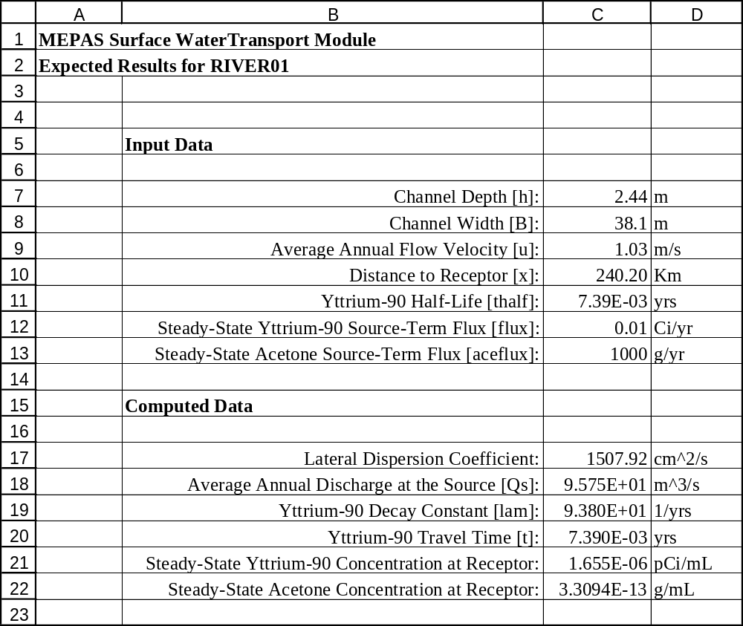

RIVER01 Expected Results.xls (formulas)

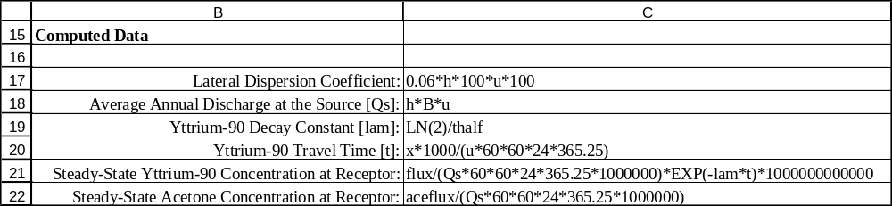

RIVER02 Expected Results.xls

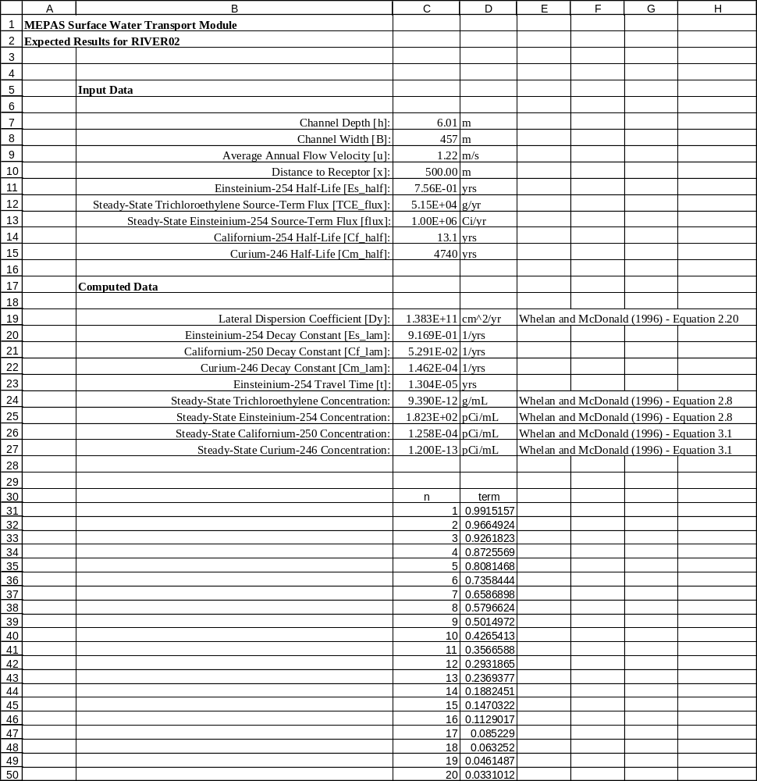
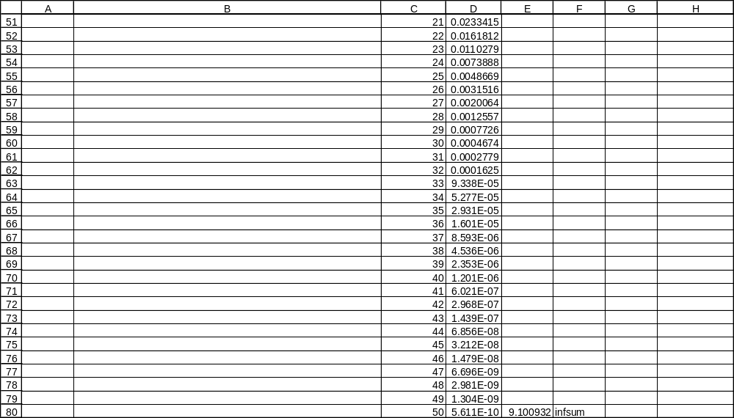
RIVER02 Expected Results.xls (formulas)

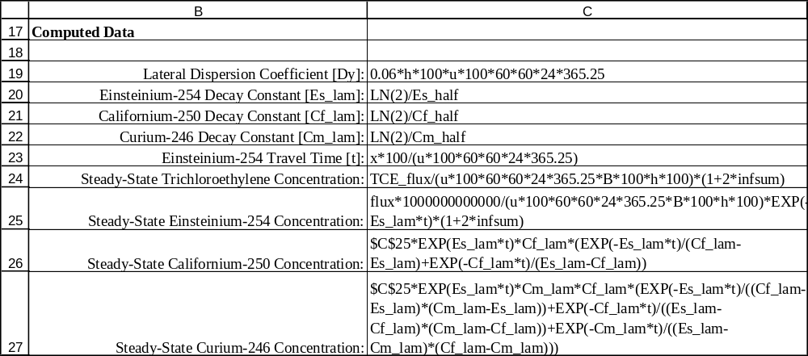

RIVER03 Expected Results.xls

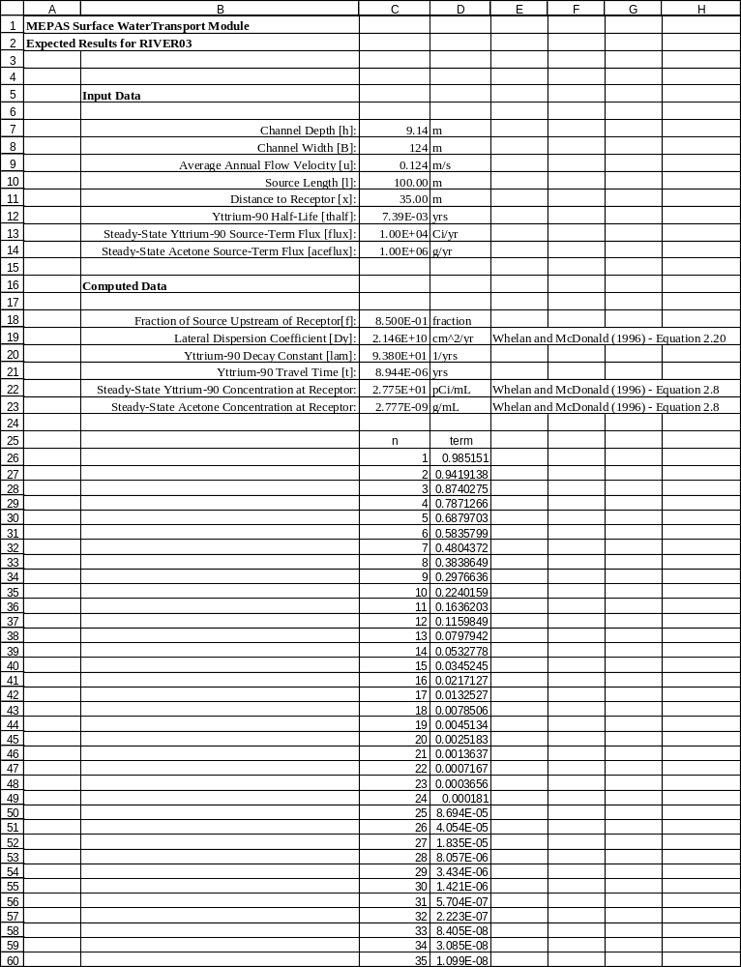

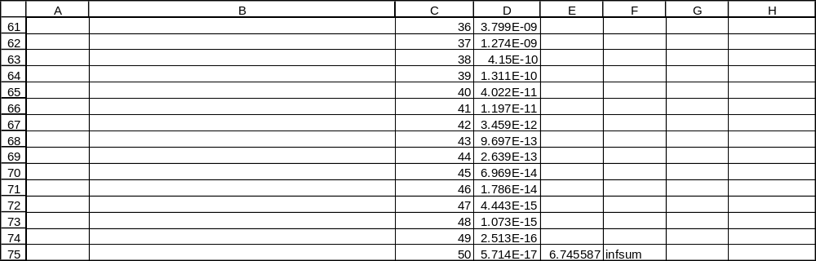
RIVER03 Expected Results.xls (formulas)

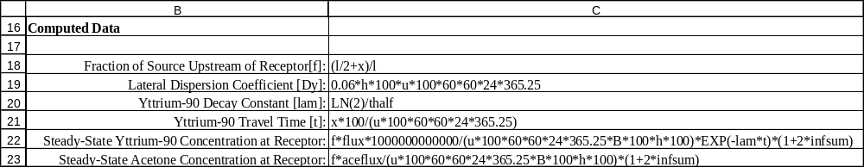
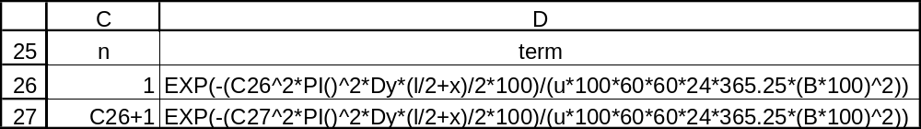
RIVER04 Expected Results.xls

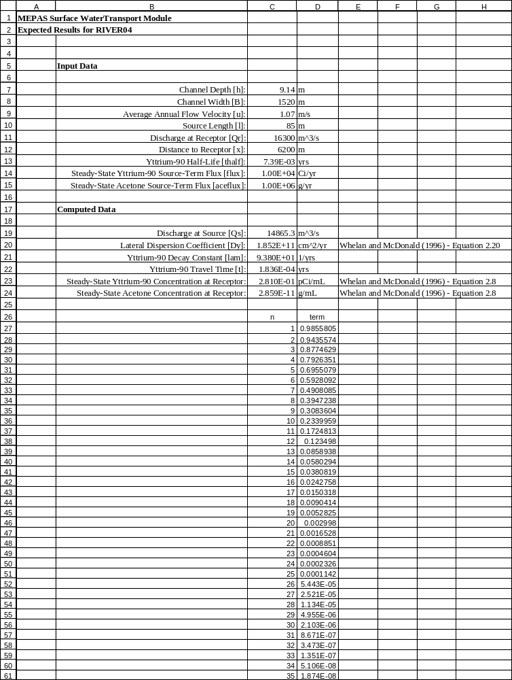

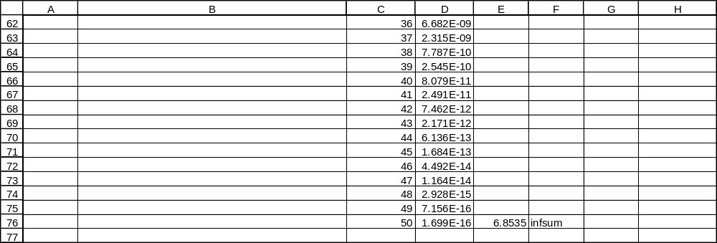
RIVER04 Expected Results.xls (formulas)

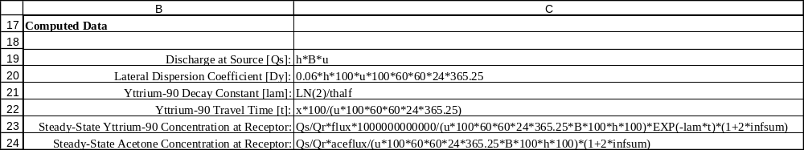
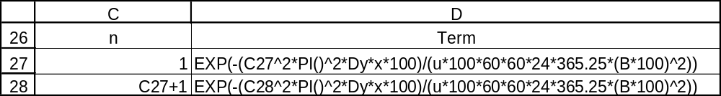

Appendix B
General Procedure for Conducting the Tests

This appendix describes the general procedure for conducting the tests in this plan. After starting FRAMES, select the contaminant icon and drag it to the workspace. Double click on this icon, click ‘OK’, name the *.GID file the same as the name of the test (e.g., vadose01), and select the contaminants to be used in the test and click ‘OK’. Then, build the rest of the conceptual-model picture by selecting the source icon and dragging it to the workspace, followed by dragging the surface water and exposure icons to the workspace. Using the right mouse button, drag from the source icon to the surface water icon to add an arrow, then drag from the surface water icon to the exposure icon.

To select a specific source model, double click on the source icon, select “MEPAS User-Defined Contaminant Emissions,” and name the icon. The user interface for this module then appears with a “Water Flux” tab only. Set the contaminated medium type to aquifer, and enter the source width and river depth into the “Width of flux plane” and “Height of flux plane” fields. The next two fields, “Distance from water table” and “Natural discharge rate,” are not used by the surface water module, so just enter zero in these fields. The next thing is to enter the water flux from the aquifer and the contaminant mass fluxes as time series. Values for the water flux are given as part of the input data for each testcase, but the values are not actually used by the surface water module. Use the drop down menu or the side-to-side arrows to select each contaminant and enter the source flux time series as defined in the input data section for the test case. After entering all the data, select “Save and Exit” from the file menu. Then, double click on the source icon to run the source module.

To enter the surface water input parameters, double click on the surface water icon, select “MEPAS Surface Water,” name the icon, and then click ‘OK’. The user interface for this module then appears. Proceed to enter the physical characteristics of the river along with the distance to each receptor. When data entry is complete, select “Save and Exit” from the file menu. Double click on the icon to run the module.

Concentration output results are contained in the *.WCF file. The viewer icon within FRAMES can be used to view these files, or a spreadsheet package can be used to load these files and plot the results. To use the viewer icon, drag it to the workspace, and drag an arrow using the right mouse button from the surface water icon to the viewer icon (dragging from the viewer icon to the surface water icon won’t work). To view the WLS and WIN files, use a text editor or word processor. These files reside in the same directory in which FRAMES is installed (usually, c:\fui) and have the names MEPAS_RV.WLS and MEPAS_RV.WIN. Each time the surface water module is executed, these files are overwritten, so they only contain information for the latest run. Rename the files if you wish to save them.

